Machine Learning Report
Data Preprocessing
Introduction:
In this report, we explain the task assigned to us, which involves performing several important data analysis steps. First, we check the dataset for any null or missing values to ensure data completeness. We then draw box plots to identify outliers and understand the distribution of variables. After that, we examine whether standardization or normalization is required based on the data’s scale and variation. We also convert the categorical target variable into a binary format for easier model processing. Once these preprocessing steps are completed, we evaluate and decide which machine-learning model is most suitable for the dataset. This structured approach helps ensure accurate and reliable results.
Check Null values:
Our CSV dataset does not contain any null or missing values, which means the data is already complete. Since no cleaning was required in this step, we proceeded directly to the next stages of analysis.

Replacing Categorial target into Binary:
we can preprocess the data by converting the categorical target variable into a binary format to make it suitable for modeling.
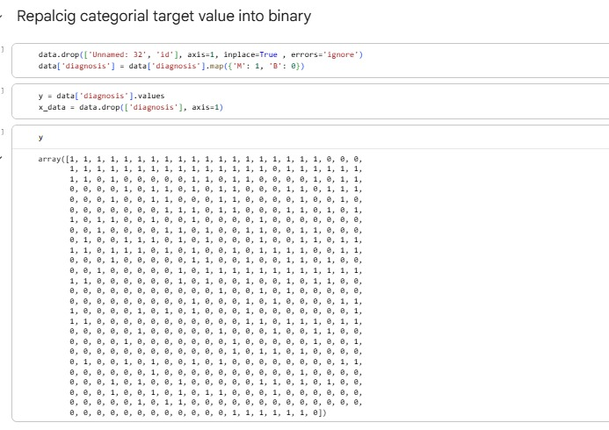

Box Plot before Standardization:
We drew box plots before applying standardization to check the distribution of the data and identify any outliers. This helps us understand how the values are spread and whether scaling is necessary.

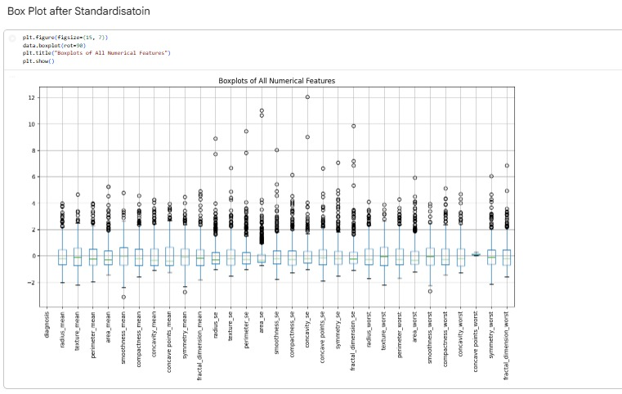

Removing Outliers by Standardization:
We used standardization to reduce the effect of outliers and bring all features onto a similar scale. This helps the data become more balanced and improves model performance.

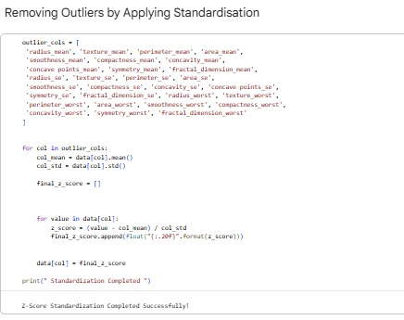

Box Plot After Standardization:
After standardization, we drew box plots again to observe how the data distribution changed. This helped us confirm whether the outliers were reduced and the values became more balanced. The post-standardization box plots showed a more uniform spread, indicating improved data quality.

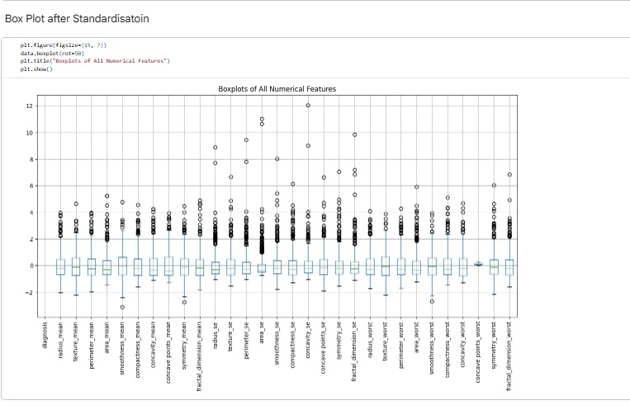

Normalization:
We applied normalization to bring all feature values into a smaller and consistent range. This helps improve model performance, especially for algorithms sensitive to scale. After normalization, the dataset became more uniform and easier to work with.

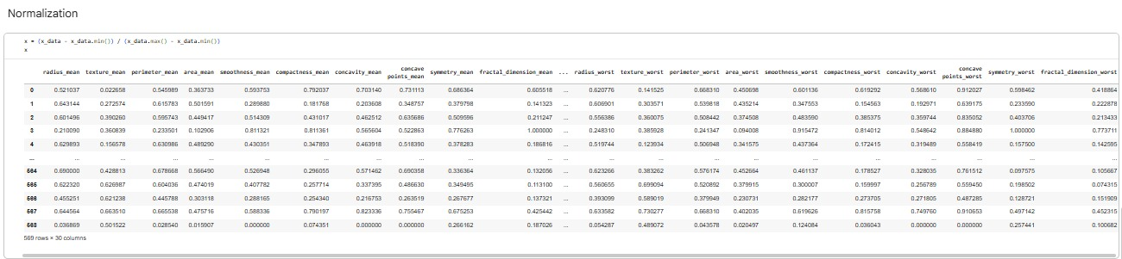

Box Plot after Normalization:
After normalization, we generated box plots again to observe the updated data distribution. These plots helped us see how the values were scaled and whether the overall spread became more uniform. The box plots showed a smoother range, indicating that normalization was effective.

